Phân trang

Trong HomeController

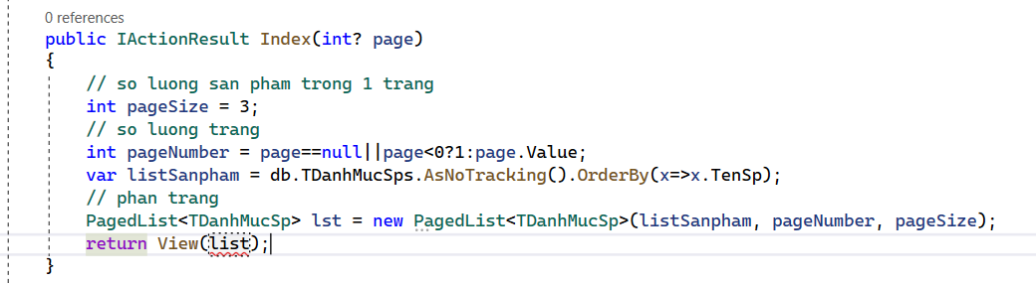

public IActionResult Index(int? page)

{

// so luong san pham trong 1 trang

int pageSize = 4;

// so luong trang

int pageNumber = page == null || page < 0 ? 1 : page.Value;

var lstCauthu = csdl.Cauthus.Where(x => x.CauLacBoId == "101").OrderBy(x => x.HoVaTen);

// phan trang

PagedList<Cauthu> list = new PagedList<Cauthu>(lstCauthu, pageNumber, pageSize);

return View(list);

}

Go to View

@using X.PagedList.Mvc.Core;

@model X.PagedList.IPagedList<Cauthu>

Thêm :

<div class="product__pagination">

@Html.PagedListPager(Model, page=>Url.Action("Index", new {page=page}))

</div>

</div>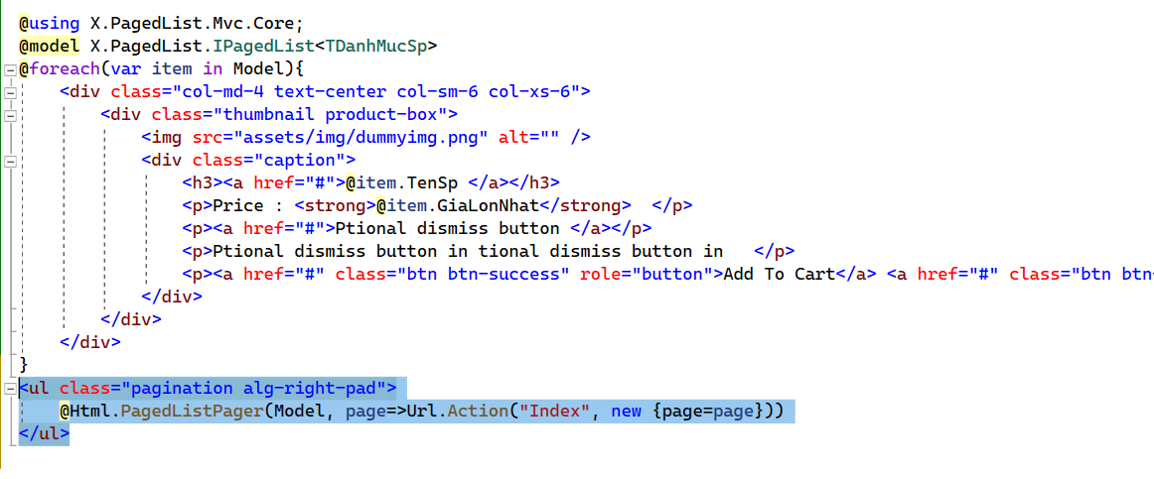

**Tạo dynamic menu bằng Component**

Tao folder moi:

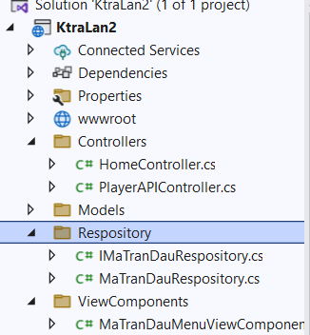

Add class -> interface: ILoaiSpRepository:

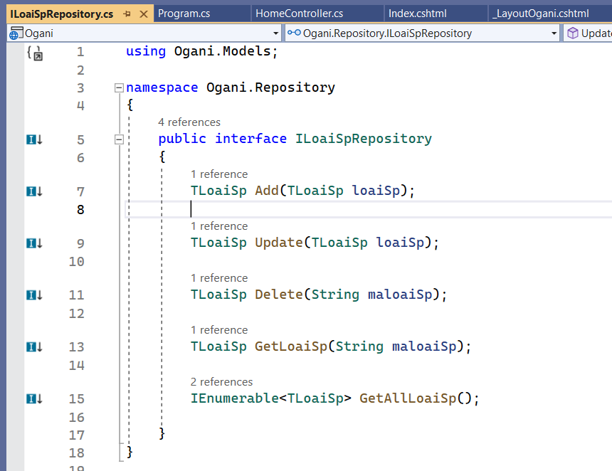

using Ogani.Models;

namespace Ogani.Repository

{

public interface ILoaiSpRepository

{

Trandau Add(Trandau trandauId);

Trandau Update(Trandau trandauId);

Trandau Delete(String trandauId);

Trandau GetTrandauId(String trandauId);

IEnumerable<Trandau> GetAllTrandauId();

}

}

**Them class LoaiSpRepository:**

public class MaTranDauRespository : IMaTranDauRespository

{

private readonly QlbongDaContext _context;

public MaTranDauRespository(QlbongDaContext context)

{

_context = context;

}

public Trandau Add(Trandau trandauId)

{

_context.Trandaus.Add(trandauId);

_context.SaveChanges();

return trandauId;

}

public Trandau Delete(string trandauId)

{

throw new NotImplementedException();

}

public IEnumerable<Trandau> GetAllTrandauId()

{

return _context.Trandaus.Take(7);

}

public Trandau GetTrandauId(string trandauId)

{

return _context.Trandaus.Find(trandauId);

}

public Trandau Update(Trandau trandauId)

{

_context.Update(trandauId);

_context.SaveChanges();

return trandauId;

}

}

**Tao folder moi ViewComponents**

using KtraLan2.Respository;

using Microsoft.AspNetCore.Mvc;

namespace KtraLan2.ViewComponents

{

public class MaTranDauMenuViewComponent : ViewComponent

{

private readonly IMaTranDauRespository _trandauId;

public MaTranDauMenuViewComponent(IMaTranDauRespository trandau)

{

_trandauId = trandau;

}

public IViewComponentResult Invoke()

{

var AllLoaiSp = _trandauId.GetAllTrandauId().OrderBy(x => x.TranDauId);

return View(AllLoaiSp);

}

}

}

Trong Shared tạo 1 folder Components -> Folder HangSxMenu -> View Default:

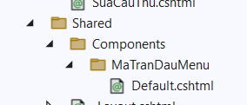

Thay the Menu cua trang (tim doan code phan Menu)

Them: @await Component.InvokeAsync("MaTranDauMenu")

**LoaiSp:**

@model IEnumerable<TLoaiSp>

<div class="col-lg-3">

<div class="hero__categories">

<div class="hero__categories__all">

<i class="fa fa-bars"></i>

<span>All departments</span>

</div>

<ul>

@foreach (var item in Model)

{

<li><a href="">@item.TranDauId</a></li>

}

</ul>

</div>

</div>

Vao Program them:

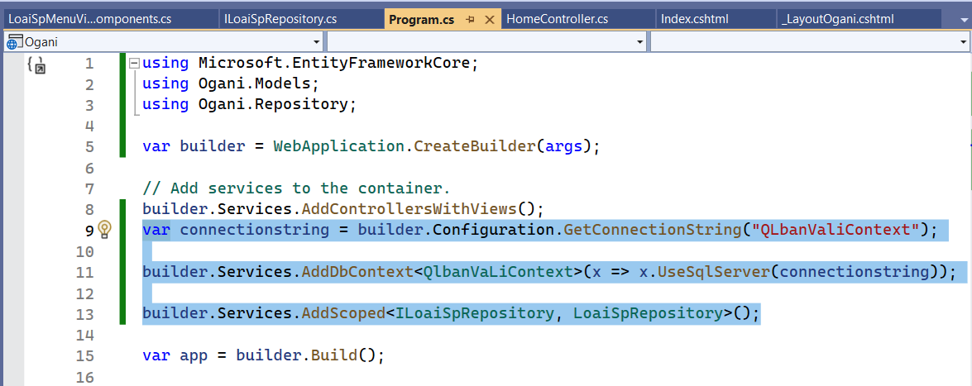

Code:

var connectionstring = builder.Configuration.GetConnectionString("QlbongDaContext");

builder.Services.AddDbContext<QlbongDaContext>(x => x.UseSqlServer(connectionstring));

builder.Services.AddScoped<IMaTranDauRespository, MaTranDauRespository>();